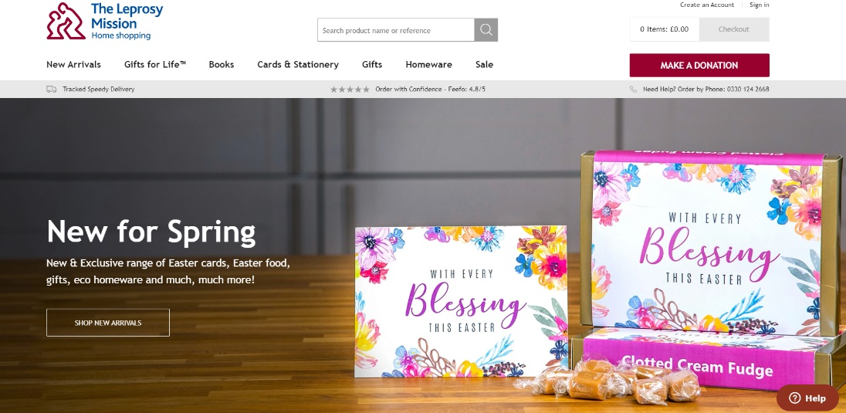
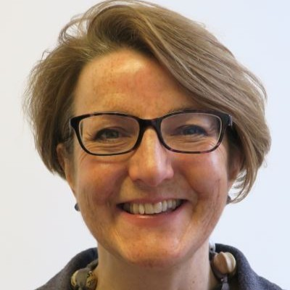

World Leprosy Day

Amanda Norman, newly appointing CEO of the Leprosy Mission Trading, spoke at our zoom chapel on Sunday 31 January, World Leprosy Day.
Why do we need a World Leprosy Day?
Many people think this ancient disease that we read about in the Bible no longer exists. It does. Every two minutes someone is diagnosed with leprosy. It is classed by the World Health Organisation as a neglected tropical disease and is still prevalent in many of the poorer countries in the world such as Brazil, Pakistan, India, Bangladesh, Nepal, Democratic Republic of Congo and Niger.
What is leprosy?
Leprosy is a mildly contagious disease that affects the nerve endings in the cooler parts of the body – eyes, nose, skin, hands, feet etc. If not treated the nerve damage can result in severe disability as patients can’t sense when they are injuring themselves. As well as the physical disabilities associated with leprosy there is still significant stigma and fear surrounding the disease.
Is leprosy curable?
Yes, since the 1980s there has been an effective treatment using a combination of relatively basic antibiotics. You take one combination for six months or a slightly different combination for twelve months if you are more seriously affected. Within two days of starting the medicine you are no longer infectious. However, if the patient is not cured in time, they may have sustained irreversible nerve damage leading to disability.
Tell us about the Leprosy Mission
The Leprosy Mission is a global Christian charity that has existed for 150 years. We have member organisations in over 30 countries. Roughly half are “supporting countries” and raise money, awareness and prayer support. The other half are “implementing countries” and carry out the project work. This includes outreach to educate people to spot the early signs of leprosy and offer medicine to newly diagnosed patients; treatment to minimize disability and rehabilitation work in vocational training centres; and advocacy work to end discrimination. We are working towards a triple zero goal
- Zero leprosy transmission by 2035
- Zero disability
- Zero discrimination
What is your role?
I am the newly appointed CEO of Leprosy Mission Trading. We are a small team based in Peterborough, selling greetings cards and gifts in aid of the Leprosy Mission. Many of our products are made by disadvantaged artisan groups in developing countries. We also sell Gifts for Life where you can make a donation to the work of the Leprosy Mission instead of buying a gift for someone. You can send them a personalized card to tell them about what you have done.
Tell us about UK Aidmatch and Darcey Bussell
For the next two months any Gifts for Life or donations for the Leprosy Mission’s work in Mozambique will be doubled by the UK government at no cost to you. Watch this video by Darcel Bussell, the prima ballerina and former judge on Strictly Come Dancing, who visited Mozambique to find out more.
To buy a Gift for Life or make a donation go to Gifts for Life | TLM Trading
Thanks very much for your interest!

